Consolidated Report Generation Instructions
Current-quarter supervisory signal-fusion reporting | Reusable master prompt | Version 2.0
Purpose: generate one coherent, auditable report from the supplied exchange records, analytical attributes and authorized supporting references. This document specifies the required report sections, fields, decision explanations and evidence standards. It is an instruction prompt, not a worked example or a predetermined assessment of any firm.

1. Reporting objective and operating principles
- Produce a current-quarter action signal identifying whether further supervisory inquiry or investigation is warranted; do not equate a signal with a finding of misconduct, financial weakness or regulatory breach.
- Organise underlying signals into supervisor-facing risk domains, then trace each domain assessment to specific question-and-answer exchanges and transcript sources.
- Retain historical comparison and directional outlook as supporting context; never allow a prior-quarter pattern to silently replace the current-quarter decision basis.
- Separate observed evidence, derived metrics, analytical interpretation, counter-evidence and recommendations. Do not invent unavailable data, confidence values, weights, thresholds or source links.
- Generate one PDF with four major report components: (A) Executive Summary, (B) Detailed Risk and Exchange Evidence, (C) Majority Decision Report, (D) Minority / Challenge Report.

2. Reporting hierarchy and document architecture
Analytical level | Purpose | Primary location
Level 1: action | One current-quarter firm-level investigation/enquiry signal | A; explained in C and challenged in D
Level 2: risk domain | Domain-level status, direction, evidence volume and interpretation | A overview; B detail
Level 3: exchange | Ranked, source-traceable exchange and question/answer evidence | B evidence register; referenced in C and D

Layout requirement: A4 landscape for the executive scorecard and tabular evidence sections; A4 portrait for the narrative Majority and Minority reports. The evidence register may run to multiple landscape pages. Preserve legibility rather than forcing all records onto one page.

3. Component A | Executive Summary (landscape)

A1. Identification and action banner
- Display firm, reporting quarter, reporting scope, run/version date and clear headline: “Current-Quarter Investigation Signal”.
- Show action level and exact label prominently, with a one-sentence interpretation and the intended supervisory response. If a five-level ladder is used, label all five levels and highlight the selected level; the illustrative sequence is 1 No Action Required, 2 Supervisory Enquiry, 3 Specialist Enquiry, 4 Regulatory Investigation, 5 Supervisory Intervention. Treat this ladder as configurable, not automatically validated.
- State the confidence/assurance qualification, including missing sources, single-quarter limitations and whether the evidence is corroborated.
- Section A1 looks like this:


A2. Compact current-quarter metric strip
- Display exchange count and coverage, deflection rate, question-answer alignment, follow-up pressure, analyst concern and any other actually available indicators.
- For each metric show value, unit/denominator, comparison baseline and historical z-score or change where calculable; mark missing/non-comparable values explicitly.
- Section A2 looks like:

A3. Decision explanation and bottom line
- Write a short “Why this signal?” paragraph: strongest supporting pattern, scope of the concern, countervailing evidence and why this level rather than an adjacent level.
- Add a concise “Bottom line” split into “What the evidence supports” and “What it cannot establish”; avoid turning transcript proxies into verified prudential findings.
- Present primary signal, strongest counter-evidence, immediate next trigger and recommended action as separate labelled fields.
- Section A3 looks like:
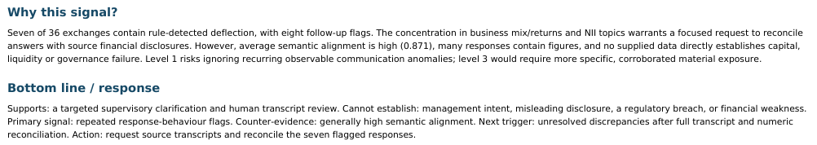

A4. Risk-domain scorecard
Required column | Instruction
Risk domain | Consistent supervisory classification; define mapping in C
Domain status / level | Stable, Watch, Escalate or configured levels; add RAG indicator with text
Direction / horizon | Improving, stable, emerging, worsening or insufficient history
Evidence volume | Number of distinct supporting signals/exchanges; define counting rule
Key current-quarter indicators | Short evidence-backed metrics, issue and exchange IDs
Counter-evidence / caveat | One short qualifier where material

Domains should be driven by supplied topic taxonomy, potentially including Capital & Solvency; Liquidity & Funding; Credit & Counterparty; Market & Balance Sheet; Operations & Technology; Business Model & Strategy; Governance, Controls & Data; Regulatory & External. Do not fabricate an assessment for a domain with no usable evidence.
Section 4A should look like this: (Note if using navy cell background, then text should be white to contrast.)
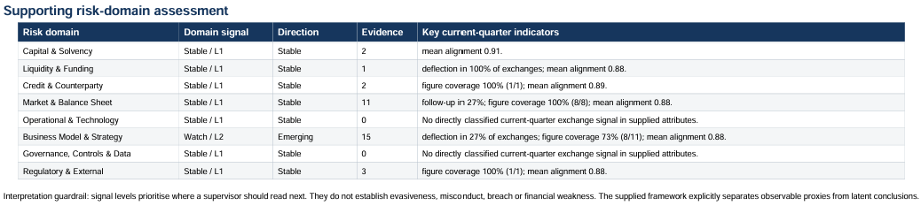

4. Component B | Detailed Risk and Exchange Evidence (landscape)

B1. Risk-domain interpretation table
- For each domain show status/RAG, domain action level, direction, evidence count, key supporting findings, mitigating facts, unresolved questions and the most relevant exchange IDs.
- Explain why the domain is monitored or stable and whether its findings are prudentially direct, indirect, commercial/contextual or unconfirmed.
- Use colour only as a supplement to a written status so the table remains accessible in monochrome.

B2. Ranked finding / evidence register
Field | Required detail
Rank, exchange_ID | Stable unique identifiers; one row per finding, linked to one or more exchanges
Firm / quarter / domain / topic | Source classification and risk-domain mapping
Analyst / manager / management speaker | Names or roles as present in exchanges.csv; do not guess
Question and answer | Faithful extracts or clearly marked truncation; preserve context
Attributes / scores | Supplied concern, alignment, hedging, deflection, follow-up, figure coverage and other available scores with units
Evidence interpretation | What was observed; why it matters; distinguish from inferred risk
Residual concern and confidence | Qualitative assessment, rationale and limits, not invented precision
Analyst attention | Count or level where available; not a substitute for risk severity
Suggested next step | Targeted question, data request, cross-check or routine monitor
Source provenance | Transcript filename/URL, page, exchange reference and deep link / Hyperlink to transcript source. See exchange.csv for original transcript and page number for source link. Try to link this to the original transcript and provide a hyperlink.

Rank findings by documented review priority or residual concern, not merely number of analyst questions. Flag uncertain and unconfirmed observations. Where complete Q&A cannot fit, include meaningful excerpts plus a functional transcript reference; never imply truncated text is complete.
Section B3 looks like this, include ranked exchanges by importance in terms of priority human checks. Note the table repeats for each exchange section. Limit evidentiary exchanges to top 10 worth investigating. Repeat – strict limit of top 10 exchanges that warrant further manual supervisor review: (Note if using navy cell background, then text should be white to contrast.)
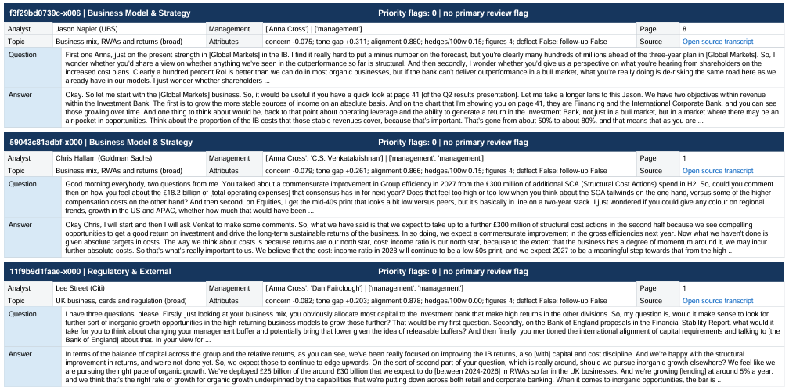

B3. Attention versus concern matrix
- Include a 2×2 matrix contrasting residual concern/criticality (low versus moderate/high, as supported) with analyst attention (low versus high).
- Place each finding by ID, brief label and attention count; define thresholds and explain that attention is not risk.
- Call out low-attention/high-concern issues and high-attention/low-concern issues for review.

B4. Follow-up request register
- Rank requests by residual concern and actionability; record finding/exchange IDs, precise information requested, rationale, proposed recipient (firm, regulator or internal data) and urgency.
- Distinguish questions answerable from existing material from requests requiring new evidence.

5. Component C | Majority Decision Report (portrait)
Write a human-readable but technically rigorous explanation of the adopted decision, with the following numbered subsections in order.

C1. Decision outcome
State selected action level, supervisory meaning, principal domains and the practical response; avoid declaring confirmed misconduct.

C2. Analytical philosophy and scope
Describe exchange-level observations as proxies, not direct measurements of evasiveness or weakness; specify sources, unit of analysis, period and exclusions.

C3. Current-quarter evidence and historical context
Tabulate key metrics with current value, baseline, z-score/change, denominator and interpretation; distinguish historical context from decision inputs.

C4. Domain classification and aggregation
Explain topic-to-domain mapping, evidence counts, overlap/deduplication, direct versus contextual relevance, domain status and direction.

C5. Signal fusion, criteria and weighting
Specify actual scoring criteria, thresholds and qualitative precedence rules: persistence, materiality, prudential relevance, corroboration, mitigation, independence and confidence. Explain how contradictory evidence affects a conclusion. If numerical weights are not provided, explicitly say qualitative weighting was used and do not invent coefficients.

C6. Why this level, not lower
Identify evidence that crosses the chosen level’s threshold and why the next-lower level would understate the credible pattern.

C7. Why not a higher level
Identify missing corroboration, mitigation, source limitations or absent severe findings that prevent escalation; state what evidence would change the level.

C8. Methods, sense checks and limitations
Describe provenance checks, consistent scoring, coverage, denominator checks, duplicate handling, unconfirmed evidence controls, missing information and sensitivity tests. Report checks as passed only when performed.

C9. Reproducible conclusion
Re-state the conclusion with traceable metrics and finding IDs; distinguish observed evidence, judgement and recommended action.

6. Component D | Minority / Challenge Report (portrait)
Present a genuine alternative assessment, not a ceremonial disclaimer. Give contradictory, excluded or underweighted evidence an explicit analytical hearing.

D1. Minority position
State the strongest defensible alternative action level or interpretation and the precise point of disagreement with the majority.

D2. Counter-evidence register
List evidence IDs, source locations, observed counter-facts, strength, reliability and which majority proposition each challenges.

D3. Reviewed but not scored
Table excluded/withheld observations with verbatim supporting evidence, why not scored (e.g. unconfirmed, indirect, weak coverage, duplicate or not prudentially direct), and what would make them admissible.

D4. Alternative weighting and sensitivity
Show how reasonable changes to materiality, confidence, corroboration, mitigation or inclusion rules could alter domain and firm-level signals. Distinguish tested outcomes from hypothetical scenarios.

D5. Competing explanations and blind spots
Discuss benign explanations, reporting/measurement artefacts, missing periods, missing financial statements and possible unobserved risks without asserting they occurred.

D6. Minority recommendation and resolution triggers
Set out an alternative supervisory action, concrete follow-up requests and objective evidence that would reconcile or overturn the disagreement.

7. Cross-cutting evidence and generation rules
- Use the supplied exchanges.csv as the source of exchange_ID, analyst, manager, question/answer, attribute values and transcript reference where those fields exist; other authorised inputs must be explicitly identified.
- Every material claim in A, C and D must reference a domain and/or finding ID resolvable in B; every finding in B must point to a real source record and, where supplied, transcript page/deep link.
- Maintain consistent firm, quarter, domain, level, count, terminology and signal definitions across all sections; reconcile differences before publishing.
- Do not silently import examples, company names, metrics, thresholds or scores from the PRIMARY or SECONDARY format illustrations into new analysis. Those examples define desired presentation, not facts about the next firm.
- Make exclusions visible. No evidence, weak evidence, contradictory evidence and evidence not scored are distinct statuses. Do not convert absence of evidence into evidence of safety.
- Use measured, accessible supervisory language. Clearly label analyst judgement, provisional classification, historical comparison and suggested follow-up.

8. Final quality and acceptance checklist
- A is concise and decision-ready: action banner, priority ladder, metric strip, “why”, bottom line, counter-evidence, next trigger and domain scorecard.
- B provides domain explanations, ranked exchange evidence, Q&A excerpts, scores, source deep links, attention-versus-concern matrix and actionable follow-ups.
- C reconstructs the majority conclusion, its weighting/aggregation logic, alternative levels, sense checks, caveats and reproducible evidence chain.
- D gives a substantive dissent: counter-evidence, not-scored register, sensitivity/alternative interpretation and resolution requests.
- All numerical values and counts are source-grounded; missing data and unperformed checks are labelled; links and cross-references are validated.
- Produce a single navigable PDF with consistent headings, page numbering, legible tables, appropriate orientation changes and a clear end-of-report marker.

9. Reusable execution instruction
Using only the provided authorised inputs, generate the complete current-quarter supervisory signal-fusion PDF in the exact sequence A → B → C → D. Populate every applicable field, mark unavailable fields explicitly, and prioritise traceable evidence over visual polish. Apply the report structure and decision logic above, while treating example layouts as design guidance rather than source evidence. If the input data or scoring rules do not support a defensible action level, state the limitation and provide a provisional evidence-led assessment rather than manufacturing a result.

